# **📘 JMeter Functions – Deep Dive with Examples**

## **🧠 What Are JMeter Functions?**

JMeter functions are **built-in keywords** that allow dynamic data creation, manipulation, and logic implementation within your test plan. They're wrapped like ${__functionName(...)} and are evaluated at runtime.

They can be used in:

* 🧪 **Samplers**
* 🧰 **Pre-/Post-processors**
* 🕵️ **Assertions**
* 🧾 **Listeners**
* 🔁 **Looping logic**

## **💡 Why Use JMeter Functions?**

| **Purpose** | **Benefit Example** |
| --- | --- |
| 🔀 Parameterization | Unique usernames, random passwords |
| ♻️ Reusability | Share values between requests |
| 🔄 Logic & Control | Conditional execution, loops |
| 🔍 Data Extraction | Capture dynamic response values |
| 🪵 Logging & Debugging | Track test execution in logs |

## **🧬 Syntax of JMeter Functions**

bash

CopyEdit

${__functionName(param1, param2, ..., varName)}

* __: All function names start with double underscores
* functionName: The name of the function (e.g., Random, time)
* param: Input values, escaped with \ if commas are involved
* varName *(optional)*: Stores result in a variable for reuse

✔️ Example:  
 ${__Random(1000,9999,myOtp)} → Generates a 4-digit random number and stores it in variable myOtp.

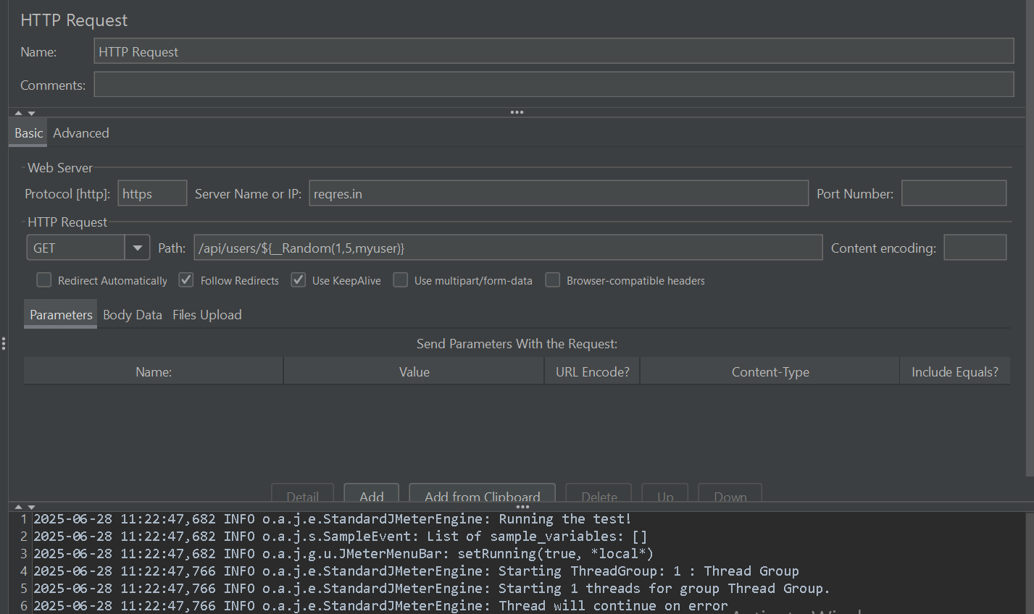

## 

## **🧭 How to Use JMeter Functions**

🧰 **Function Helper Dialog**

1. Go to Options > Function Helper Dialog
2. Select a function
3. Enter parameters
4. Click "Generate"
5. Copy the generated string and paste into your test element  
   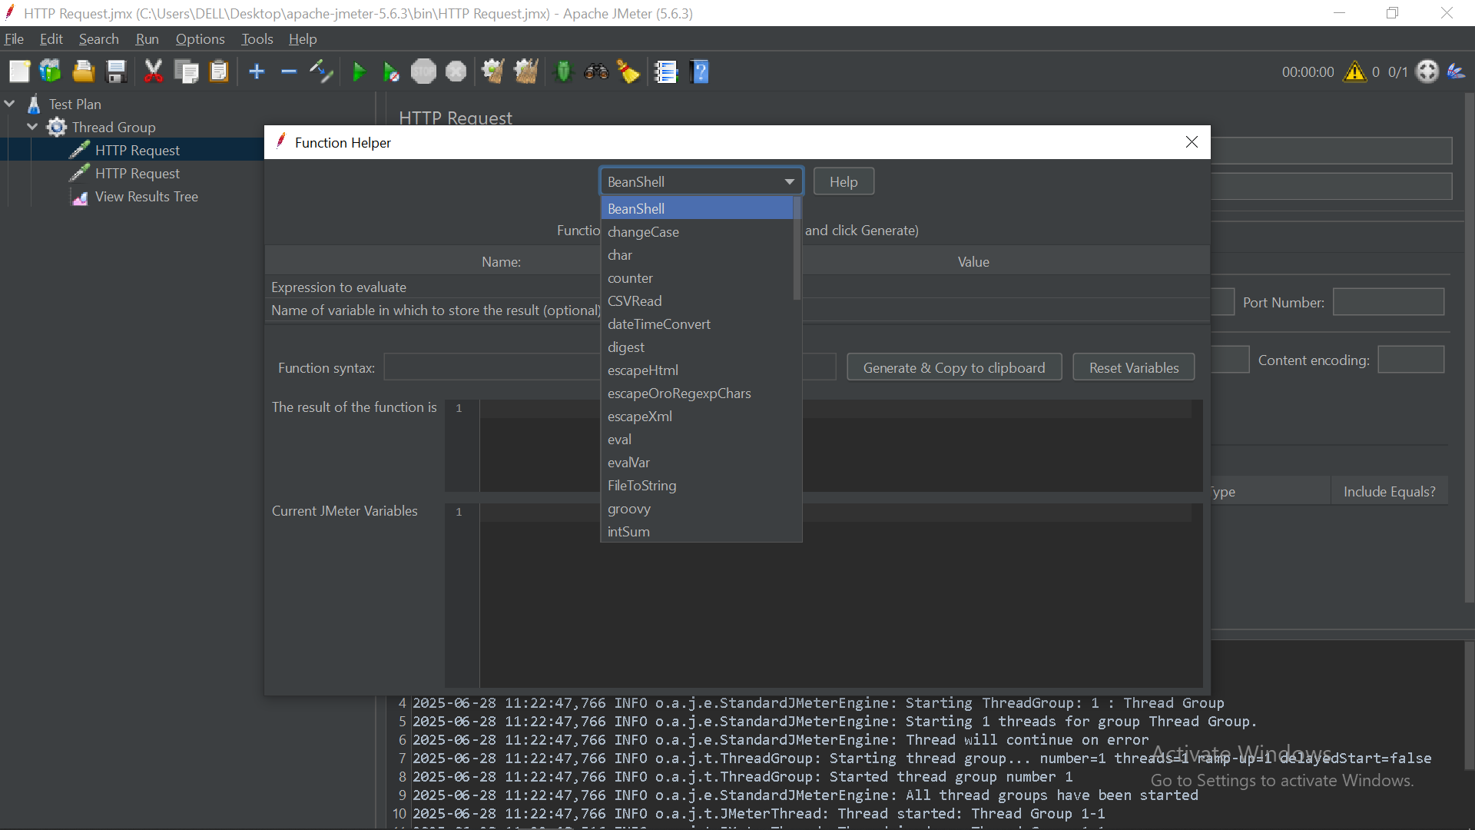

## **🗂️ Categories of JMeter Functions with Examples**

### **1️⃣ Information Functions**

📌 Used to get metadata about test execution

| **Function** | **Description** | **Example Output** |
| --- | --- | --- |
| ${__threadNum()} | Returns thread number | 3 |
| ${__threadGroupName()} | Returns thread group name | UserGroup1 |
| ${__time(yyyyMMdd_HHmmss)} | Current time in format | 20250627_221545 |
| ${__machineIP()} | Returns local IP address | 192.168.1.10 |
| ${__log(MyMsg, info)} | Logs message to JMeter log | Writes to jmeter.log |

### 

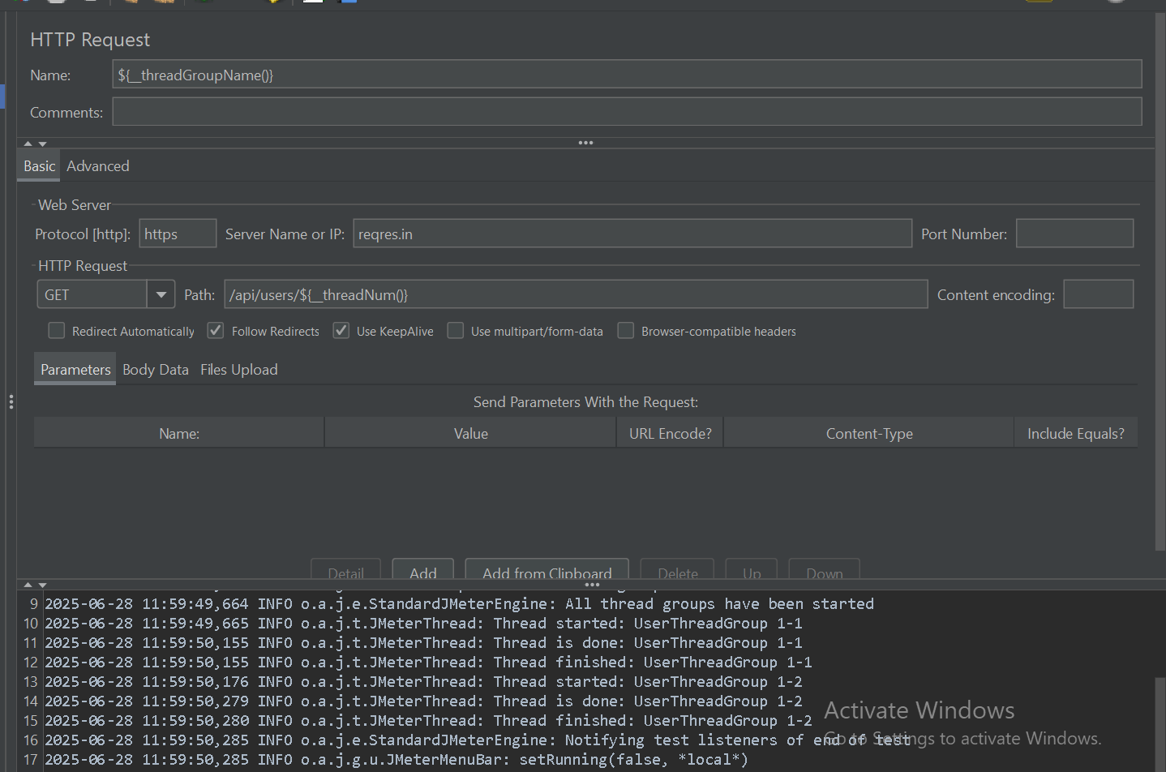

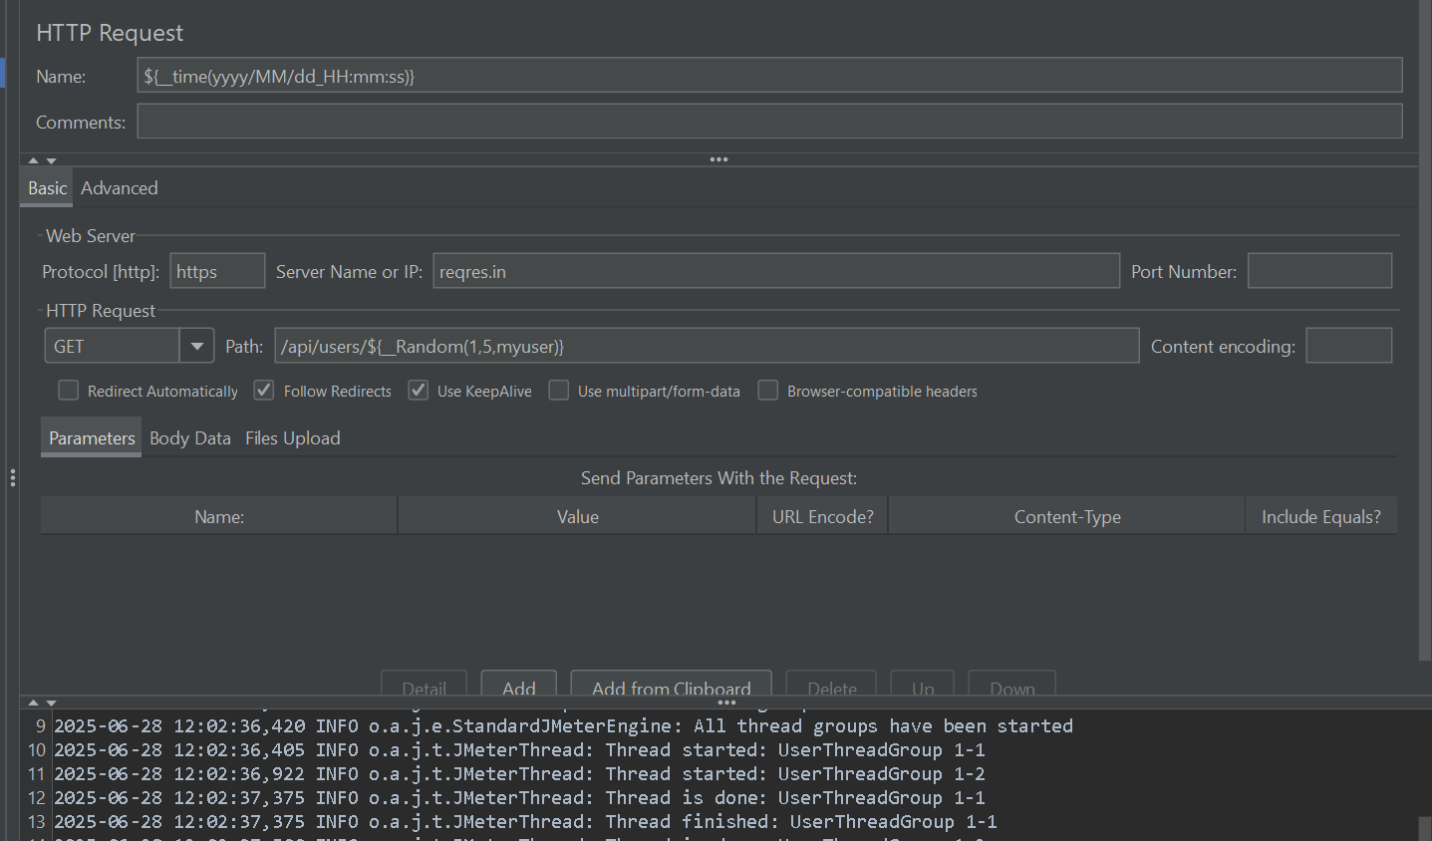

### **2️⃣ Input Functions**

📄 Read data from files

| **Function** | **Description** |
| --- | --- |
| ${__CSVRead(data.csv, 0)} | Reads 1st column from data.csv |
| ${__StringFromFile(file.txt, var, 0,10)} | Reads characters from file |
| ${__FileToString(file.txt, UTF-8)} | Reads whole file as a string |

### **3️⃣ Calculation Functions**

🔢 Math and random generation

| **Function** | **Description** |
| --- | --- |
| ${__counter(true, userCount)} | Global counter across all threads |
| ${__Random(1, 100, randNum)} | Random int between 1–100 |
| ${__RandomString(6, abc123, otp)} | Random 6-char string from abc123 |
| ${__UUID()} | Generates UUID |
| ${__intSum(10, 20, sum)} | Returns 30 |

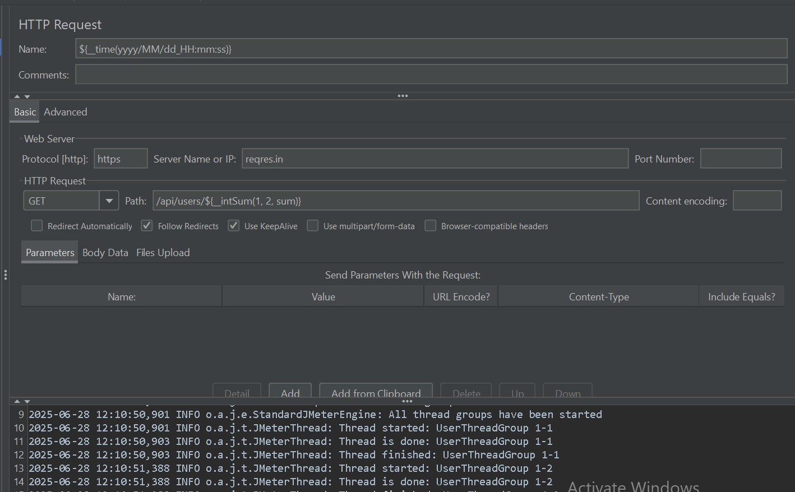

### **4️⃣ Scripting Functions**

⚙️ Use scripting languages

| **Function** | **Description** |
| --- | --- |
| ${__groovy('return 2+2', myVar)} | Executes Groovy code |
| ${__BeanShell('vars.get("user")')} | Executes BeanShell script |
| ${__jexl3(1+1, x)} | Evaluates JEXL3 expression |

📝 **Groovy is preferred** over BeanShell for performance.

### **5️⃣ Properties Functions**

🔐 Read/write global JMeter properties

| **Function** | **Description** |
| --- | --- |
| ${__property(myProp, defaultVal)} | Reads property |
| ${__setProperty(myProp, 123)} | Sets property |

### **6️⃣ Variables Functions**

🧩 Manipulate JMeter variables

| **Function** | **Description** |
| --- | --- |
| ${__split("user:pass", cred, ":")} | Splits into ${cred_1}, ${cred_2} |
| ${__V(varName)} | Dynamically evaluates variable |
| ${__eval(${myExpr})} | Evaluates value of a variable expression |

### **7️⃣ String Functions**

🔤 Encode, decode, manipulate strings

| **Function** | **Description** |
| --- | --- |
| ${__urlencode("a@b.com")} | Returns a%40b.com |
| ${__urldecode("a%20b")} | Returns a b |
| ${__regexFunction('name=(\w+)', 1, 1, $1)} | Extracts value from response using regex |

## **⚠️ Important Considerations**

| **Item** | **Notes** |
| --- | --- |
| ⏱️ Performance | Use __groovy over BeanShell for faster execution |
| 🔁 Scope | Some functions are **global** (__counter(true)), some per-thread |
| 🔡 Commas in Params | Escape commas in strings using \ |
| 🧪 Debugging | Use ${__log(...)} or View Results Tree to inspect runtime values |

## **✅ Example Test Use Case**

**Use Case**: Generate unique username and log it

bash

CopyEdit

${__RandomString(6, abcdefghijkl, user)}

${__log(GeneratedUser: ${user}, info)}